Coursework 2.1 – Design & Modelling

CIS4503 Databases
Shirley Hunter Barnett & Collette Gavan
Kate Forshaw
25259628

Word count: 3002

Contents
Introduction ………………………………………………………………………………… 3
Ambiguities …………………………………………………………………………………. 3
Assumptions ………………………………………………………………………………… 4
Database design …………………………………………………………………………….. 6
ERD – draft …………………………………………………………………………. 6
Normalisation ………………………………………………………………………. 7
ERD – final …………………………………………………………………………. 8
Data dictionary …………………………………………………………………….. 9
References …………………………………………………………………………………. 19
Appendix …………………………………………………………………………………... 22
Introduction
This report contains the process of the design and modelling of a database for a music festival event management system. The process begins by stating anything with ambiguity in the festival scenario and finding a solution for clarity. The assumptions made regarding the scenario will then be presented. A definition of an entity relationship diagram (ERD) will be given along with the first draft of the ERD for the festival scenario. Following, the description of normalisation and explanation of its course the entities and attributes took to be classified as third normal form (3NF). The report will return its focus to the ERD, revealing the final diagram and justifying any choices made concerning its relationships. There will then be a full data dictionary containing all entity tables, detailing their attributes’ description, data type, field size, and required field.
The event management system is being created for a fictional festival called Sunbeat Music Festival. This festival hosts 42 artists with a variety of genres, such as pop music from Lady Baba and folk, rap, and electronic music from Post Malogne, amongst 5 different stages. Alongside this are alternative entertainments consisting of comedy, food, films, and many more, which all take place over the space of 3 days. Its diversity of holding musical and non-musical events allows for greater fulfilment for the different kinds of people attending the festival. There is a numerous amount of ticket options where an attendee can be at the festival for just one day, two days, or even the full weekend. If they are staying multiple days, they will gain the option of reserving a camping spot. The festival even has VIP options for tickets, granting attendees prime viewing areas and backstage access.
Ambiguities
When reading about the fictional Sunbeat Music Festival, it was noticeable that some of the stages names alter when listed in different points of the scenario – first as Main, East, West, Tent, and Acoustic, second as Main Stage, Groove Ground, Acoustic Corner, Rock Riff Ridge, and Chillout Lounge. It is not clear which stage corresponds to each and for the database they should resort to having one singular name, perhaps the second ones as they are repeated with the list of performances on each stage, to avoid confusion.
Something else that could be understood differently, is the festival entry tickets. There are so many varied options and details that could affect the price of the ticket, making the ticket quite complex. This can be fixed through considering ticket and ticket type as separate entities. Therefore, an attendee can specify what type of pass they would like (day or multi-day), which days they would like to be there, and if they want VIP access or not. They can then move on to the next stage of opting in or out of camping, and their price of their ticket will be determined by all these factors.
Assumptions
- Some artists will be playing multiple performances; therefore, performance should be its own entity to differentiate between the same artist’s different performances.
- An attendee can purchase multiple entry tickets as they most likely will not be attending by themselves, but there should be a limit to how many they can buy.
- There is a maximum capacity for the festival to avoid overcrowding, so they can only sell a certain number of tickets (perhaps approximately 100,000)
- There is a maximum capacity for VIP tickets to exaggerate the feeling of exclusivity, and as there will be limited space in premium viewing areas.
- There is a maximum capacity for camping spots, which is likely to be less than the ticket capacity as more than one attendee will share a tent.
- As well as the Food and Brew Street, there are other food vendors located around the festival, so there are a variety of food options for attendees.
- There is a line-up of upcoming performances and non-music events, so attendees, and the artists themselves, know when and where to go to see their preferred entertainment.
- There are staff who manage the entrance, stages, non-music events, and line-ups, to maintain festival organization and keep it running normally.
- There is a maximum capacity for number of attendees at a stage, and it varies depending on which stage they are at.
Database Design
Entity Relationship Diagram - Draft
The entity relationship diagram (ERD) was created as an instrument for database design, which can be viewed as a blend of the relational model, the network model, and the entity set model (Chen, 1976). Cagiltay et al. (2013) argued that for a visionary data model, which the data requirements are expressed in a database system, it is predominant in its diagrammatic portrayal. An ERD consists of two or more entities and their relationships with one another, accounting for optionality and cardinality. An entity is an embodiment of a distinctive noun or object that is exhibited in a database (Thalheim, 2013). The relationship between two entities is expressed by a verb and a line connecting the two. Optionality specifies whether the relationship is optional or mandatory – optional is represented by a circle and mandatory by a line perpendicular to the relationship line. Cardinality refers to how many are part of the relationship. There is a one to one (1:1) relationship, a one to many (1:M), and a many to many (M:M). The cardinality of many can be denoted with a crow’s foot from the entity box to the relationship line. If there is a many to many relationship, it is recommended to create a new entity connecting the original entities as a database can only enforce a one tot one or one to many relationship (Frolik, 2021).
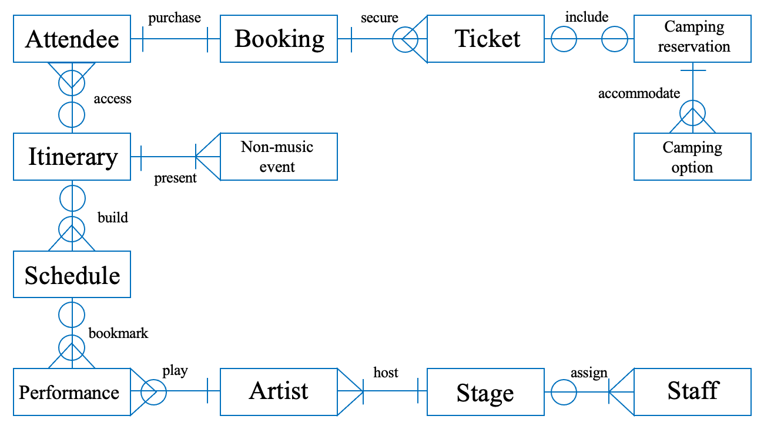
Figure 1 First draft of ERD for Sunbeat Musical Festival management system
Normalisation
Proposed by Codd, normalisation aims to resolve data redundancy and update anomalies through the construction of tables (Sikora, 1997). Data redundancy is described as the data that ceases to be of use any longer (Chen et al., 2023). An update anomaly is when the same data (redundant data) is modified in one record but not another, leading to inconsistencies occurring (Science Direct, 2003). Normalisation is made up of 7 stages/normal forms: first (1NF), second (2NF), third (3NF), Boyce-Codd, fourth, fifth, and domain-key. When progressing from one stage to another, the development of normalisation advances. If a relation does not have repetitive groups of data items, it can be labelled as 1NF. For a relation to be classed as 2NF, it should first be 1NF while not containing non-key attributes that are partially dependent upon the key. This implies that attributes should be functionally dependent, signifying the value of one uniquely determines the value of another, which is valuable for cleansing data (Papenbrock et al., 2015). For a relation to be in 3NF it must battle the concept of transitive dependency. This occurs when there are 3 or more attributes and the non-key attributes are dependent on one another, rather than solely on the primary key (PK) (Noor). If transitive dependency is present, the attribute should be moved to a new entity table, in order for the current relation be in 3NF.
Each of the entities for the festival scenario are in third normal form (see appendix 1) as all repeating data has been removed, entities have a unique identifier (primary key), and any attributes independent to the PK are no longer present. For example, the entity table for stage consists of two attributes: stage ID (PK) and stage name.
Entity Relationship Diagram – Final
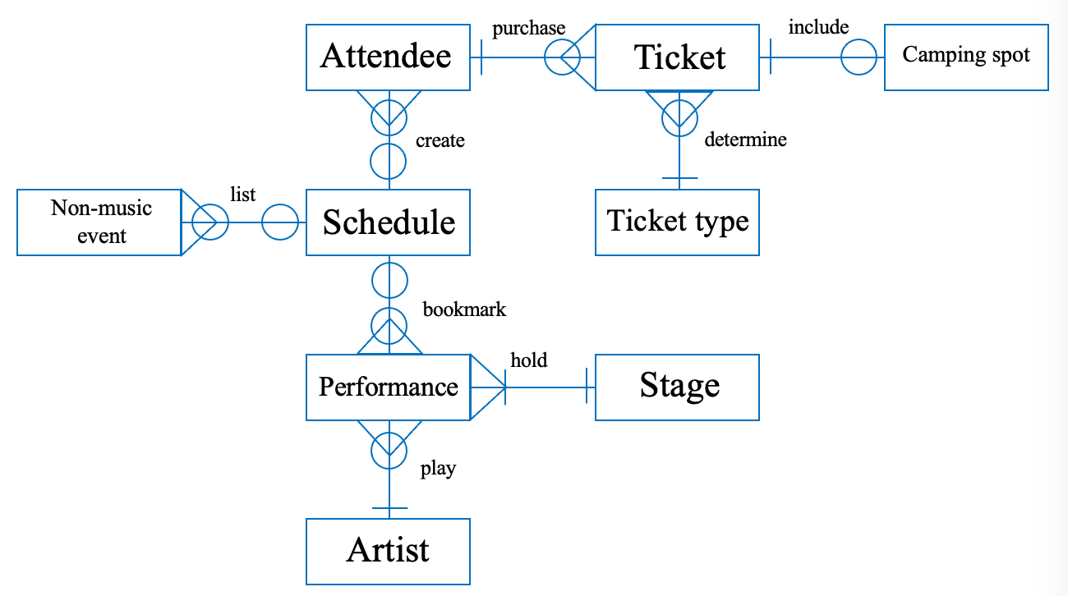
Figure 2 Final draft of ERD for Sunbeat Music Festival management system
An attendee may purchase many tickets as they have the option to buy tickets for who they are attending with but can just buy their own. A ticket must be purchased by an attendee as they cannot attend the festival if they do not have a ticket.
A ticket must be determined by a ticket type as the price of the ticket is dependent on the type of ticket purchased. A ticket type may determine many tickets as the number of tickets determined is dependent on whether more than one of every ticket type is chosen, which is unknown until after ticket sales.
A ticket may include a camping spot as attendees have the option to camp if they are there multiple days, but it is not mandatory. A camping spot must be included on a ticket as an attendee will not be able to camp if it is not stated on their ticket.
An attendee may create a schedule as some attendees might not want to miss performances or events high in their priorities and others might prefer to enjoy the festival more loosely without a schedule. A schedule may be created by many attendees as more than one attendee might want to plan out their day/weekend.
A schedule may list many non-music events as an attendee might prefer to attend the alternative entertainment rather than the performances. A non-music event may be listed on a schedule as it does not need to be listed for an attendee to go to it.
A schedule may bookmark many performances as an attendee might have multiple highly prioritised performances or just the one. A performance may be bookmarked by a schedule it does not need to be bookmarked for an attendee to go to it.
A performance must be held on a stage as the stage is the location an attendee watches the performance. A stage must hold many performances as there are up to 50 performances every day and only 5 stages.
A performance must be played by an artist as there is no performance if there is not an artist to play it. An artist may play many performances as some, not all, artists are scheduled to play multiple times over the weekend.
Data Dictionary
Harvard University (2025) defines a data dictionary as document which summarizes a collection of data in a dataset with its variable definition, content, and structure, all for the purpose of supplying a variety of techniques to ease data management control (Uhrowczik, 1973). These techniques refer to describing a data element while also providing its data type, what they contain, its field size, specific standards applied and if it is a required field or not (Thompson, 1999). The data elements, also known as entities, are consolidated into tables, leading to the creation of the database. A data type infers what an attribute can occupy, for instance, time, date, numeric, and string (W3schools, 2025). Examples of data types for MySQL are VARCHAR, TINYINT, and BINARY. An attribute’s field size is the maximum capacity of characters the data field desires, essentially verifying the storage size (DePaul University, 2025). Its required field refers to whether an attribute is mandatory or not – if it is mandatory, a record cannot be saved until a value is entered for it. Mandatory attributes are written as not null and optional attributes as null, stating the column can be left empty.
Table 1
Entity table for artist
Artist

Attribute | Description | Data Type | Field Size | Required Field
Artist ID (PK) | Unique identification number consisting of 3 letters of artist and 7 digits increased by 1 each time a new one is entered, e.g., ART0000001 | CHAR | 10 | Not null
Artist name | The name of band or solo artist | VARCHAR | 50 | Not null
Music genre | The type of music the artist plays | VARCHAR | 50 | Not null

In the artist entity table, the attributes listed are artist ID, artist name, and music genre (see table 1). CHAR was indicated as the data type for artist ID as it has a fixed length string of 10 letters and numbers, 3 of which are letters in artist (ART) and 7 of which are digits that rise by 1 each time there is a new artist ID added. Both artist name and music genre were noted down as VARCHAR with a maximum of 50 characters as the names of some bands can be significantly longer than others, and artists could play multiple different music genres, and both may contain special characters.
Table 2
Entity table for attendee
Attendee

Attribute | Description | Data Type | Field Size | Required Field
Attendee ID (PK) | Unique identification number consisting of 3 letters of attendee and 7 digits increased by 1 each time a new one is entered, e.g., ATD0000001 | CHAR | 10 | Not null
Forename | The first name of the attendee | VARCHAR | 50 | Not null
Surname | The last name of the attendee | VARCHAR | 50 | Not null
Date of birth | Attendee’s date of birth written in format YYYY-MM-DD | DATE | 10 | Not null
Email address | The email address of the attendee | VARCHAR | 100 | Null
Phone number | The phone number of the attendee | BIGINT | 15 | Not null

In the attendee entity table, the attributes listed are attendee ID, forename, surname, date of birth, email address and phone number (see table 2). CHAR was indicated as the data type for attendee ID as it has a fixed length string of 10 letters and numbers, 3 of which are letters in attendee (ATD) and 7 of which are digits that rise by 1 each time there is a new attendee ID added. Both forename and surname were noted down as VARCHAR with a maximum of 50 characters due to attendees potentially having double barrel first and last names, meaning they contain special characters. VARCHAR is also stated as the datatype of email address, allowing up to 100 characters as this will contain letters and special characters, letters of which are likely an attendee’s full name. Moreover, this field is null as not every attendee might have an email to provide. An attendee does need to provide a phone number though, which has the data type BIGINT with 15 characters as phone numbers are large integers.
Table 3
Entity table for camping spot
Camping spot

Attribute | Description | Data Type | Field Size | Required Field
Camp spot ID (PK) | Unique identification number consisting of 3 letters of camping spot and 7 digits increased by 1 each time a new one is entered, e.g., CPS0000001 | CHAR | 10 | Not null
Camping type | Specifies whether it is ‘basic’ or ‘premium’ camping | ENUM | 7 | Not null

In the camping spot entity table, the attributes listed are camp spot ID and camping type (see table 3). CHAR was indicated as the data type for camp spot ID as it has a fixed length string of 10 letters and numbers, 3 of which are letters in camping spot (CPS) and 7 of which are digits that rise by 1 each time there is a new camp spot ID added. Camping type is demonstrated by the data type ENUM and is allowed up to 7 characters as an attendee can only choose one of two options for camping, basic or premium, and premium is 7 characters long.
Table 4
Entity table for non-musical event
Non-musical event

Attribute | Description | Data Type | Field Size | Required Field
NM Event ID (PK) | Unique identification number consisting of 3 letters of non-musical event and 7 digits increased by 1 each time a new one is entered, e.g., NME0000001 | CHAR | 10 | Not null
Event name | The name of the non-musical event | TINYTEXT | 20 | Not null
Event type | Specifies what kind of entertainment the event is, e.g., food, health, comedy, etc | TINYTEXT | 40 | Not null

In the non-musical event entity table, the attributes listed are NM event ID, event name, and event type (see table 4). CHAR was indicated as the data type for NM event ID as it has a fixed length string of 10 letters and numbers, 3 of which are letters in non-musical event (NME) and 7 of which are digits that rise by 1 each time there is a new NM event ID added. Both event name and type are noted down as the data type TINYTEXT; event name with a maximum 20 characters as there is no non-musical event with a name longer than that, and event type with 40 characters as a non-musical event could provide more than one kind of entertainment.
Table 5
Entity table for performance
Performance

Attribute | Description | Data Type | Field Size | Required Field
Performance ID (PK) | Unique identification number consisting of 3 letters of performance and 7 digits increased by 1 each time a new one is entered, e.g., PFM0000001 | CHAR | 10 | Not null
Performance type | Specifies the theme of the performance, e.g., nautical, animal, news, etc | TINYTEXT | 30 | Not null
Artist ID (FK) | Unique identification number consisting of 3 letters of artist and 7 digits increased by 1 each time a new one is entered, e.g., ART0000001 | CHAR | 10 | Not null
Stage ID (FK) | Unique identification number consisting of 3 letters of stage and 7 digits increased by 1 each time a new one is entered, e.g., STG0000001 | CHAR | 10 | Not null

In the performance entity table, the attributes listed are performance ID, performance type, artist ID and stage ID (see table 5). CHAR was indicated as the data type for performance ID as it has a fixed length string of 10 letters and numbers, 3 of which are letters in performance (PFM) and 7 of which are digits that rise by 1 each time there is a new performance ID added. Performance type is demonstrated with TINYTEXT as its data type and up to 30 characters as there could be a couple different themes for one performance. Artist ID and stage ID are required fields as the performance needs someone performing and a location.
Table 6
Entity table for schedule
Schedule

Attribute | Description | Data Type | Field Size | Required Field
Schedule ID (PK) | Unique identification number consisting of 3 letters of schedule and 7 digits increased by 1 each time a new one is entered, e.g., SCH0000001 | CHAR | 10 | Not null
Reminder | States whether a notification is set for up-comings in their personal schedule, e.g., 0 – false, 1 – true | BOOL | 1 | Not null
Priority level | States the degree of priority to attend as low, medium, or high | ENUM | 7 | Null
Attendee ID (FK) | Unique identification number consisting of 3 letters of attendee and 7 digits increased by 1 each time a new one is entered, e.g., ATD0000001 | CHAR | 10 | Not null
Performance ID (FK) | Unique identification number consisting of 3 letters of performance and 7 digits increased by 1 each time a new one is entered, e.g., PFM0000001 | CHAR | 10 | Not null
NM Event ID (FK) | Unique identification number consisting of 3 letters of non-musical event and 7 digits increased by 1 each time a new one is entered, e.g., NME0000001 | CHAR | 10 | Null

In the schedule entity table, the attributes listed are schedule ID, reminder, priority level, attendee ID, performance ID and NM event ID (see table 6). CHAR was indicated as the data type for schedule ID as it has a fixed length string of 10 letters and numbers, 3 of which are letters in schedule (SCH) and 7 of which are digits that rise by 1 each time there is a new schedule ID added. Reminder is represented by the data type BOOL with the length 1 as it uses the umbers 0 and 1 to state whether it is true or false if an attendee has a reminder set for their personal schedule. ENUM is shown as the data type for priority level to allow for multiple choice of ‘low’, ‘medium’, or ‘high’, and medium is the longest option, so the length of the field is 7 characters. This field is null as it is not necessary for an attendee to essentially rate their performance or event priority. Attendee ID and performance ID are required fields as this indicates whose personal schedule it is and which performances it consists of. However, NM event ID is not required as attendees do not need to list a non-musical event in their schedule.
Table 7
Entity table for stage
Stage

Attribute | Description | Data Type | Field Size | Required Field
Stage ID (PK) | Unique identification number consisting of 3 letters of stage and 7 digits increased by 1 each time a new one is entered, e.g., STG0000001 | CHAR | 10 | Not null
Stage name | The name of the stage, options are: Main Stage, Groove Ground, Acoustic Corner, Rock Riff Ridge, and Chillout Lounge | TINYTEXT | 15 | Not null

In the stage entity table, the attributes listed are stage ID and stage name (see table 7). CHAR was indicated as the data type for stage ID as it has a fixed length string of 10 letters and numbers, 3 of which are letters in stage (STG) and 7 of which are digits that rise by 1 each time there is a new stage ID added. Stage name is demonstrated as the data type TINYTEXT with a length of 15 characters as there is no stage with a name longer than that.
Table 8
Entity table for ticket
Ticket

Attribute | Description | Data Type | Field Size | Required Field
Ticket ID (PK) | Unique identification number consisting of 3 letters of ticket and 7 digits increased by 1 each time a new one is entered, e.g., TIC0000001 | CHAR | 10 | Not null
Price | The total price of the ticket in pounds | DECIMAL | 5 | Not Null
Valid from | States the date the ticket can be used from | DATE | 10 | Not null
Valid till | States the date the ticket can be used till | DATE | 10 | Not Null
Attendee ID (FK) | Unique identification number consisting of 3 letters of attendee and 7 digits increased by 1 each time a new one is entered, e.g., ATD0000001 | CHAR | 10 | Not null
Ticket type ID (FK) | Unique identification number consisting of 3 letters of ticket type and 7 digits increased by 1 each time a new one is entered, e.g., TYP0000001 | CHAR | 10 | Not null
Camp spot ID (FK) | Unique identification number consisting of 3 letters of camping spot and 7 digits increased by 1 each time a new one is entered, e.g., CPS0000001 | CHAR | 10 | Null

In the ticket entity table, the attributes listed are ticket ID, price, valid from, valid till, attendee ID, ticket type ID and camp spot ID (see table 8). CHAR was indicated as the data type for ticket ID as it has a fixed length string of 10 letters and numbers, 3 of which are letters in ticket (TIC) and 7 of which are digits that rise by 1 each time there is a new ticket ID added. Both valid from and till are noted down with the data type DATE to represent what days an attendee’s ticket is valid for. Attendee ID and ticket type ID are required fields as the owner of the ticket and the ticket types they have chosen need to be known. However, camp spot ID is a null field as camping is optional at the festival.
Table 9
Entity table for ticket type
Ticket type

Attribute | Description | Data Type | Field Size | Required Field
Ticket type ID (PK) | Unique identification number consisting of 3 letters of ticket type and 7 digits increased by 1 each time a new one is entered, e.g., TYP0000001 | CHAR | 10 | Not null
Entry days | Indicates which days the attendees have entry for | TINYTEXT | 7 | Not null
VIP | Specifies if it is a VIP ticket or not (0 – false, 1 – true) | BOOL | 1 | Not null

In the ticket type entity table, the attributes listed are ticket type ID, entry days, and VIP (see table 9). CHAR was indicated as the data type for ticket type ID as it has a fixed length string of 10 letters and numbers, 3 of which are letters in ticket type (TYP) and 7 of which are digits that rise by 1 each time there is a new ticket type ID added. Entry days has TINYTEXT stated as its data type with a small field size of 7 characters as an attendee must say which days they want to attend the festival and Saturday is the longest day in the weekend, which is 7 letters long. BOOL is presented as the data type for VIP to say whether it true or false if the attendee has a VIP ticket, with 0 and 1.
References
CAGILTAY, N.E., TOKDEMIR, G., KILIC, O., and TOPALLI, D., 2013. Performing and analyzing non-formal inspections of entity relationship diagram (ERD). The Journal of systems and software [online]. 86 (8), pp. 2184–2195. Available from: http://dx.doi.org/10.1016/j.jss.2013.03.106.
CHEN, J.-A., NIU, W., REN, B., WANG, Y., and SHEN, X., 2022. Survey: Exploiting data redundancy for optimization of deep learning. ACM computing surveys [online]. Available from: http://dx.doi.org/10.1145/3564663.
CHEN, P.P.-S., 1976. The entity-relationship model—toward a unified view of data. ACM transactions on database systems [online]. 1 (1), pp. 9–36. Available from: http://dx.doi.org/10.1145/320434.320440.
DEPAUL UNIVERSITY, 2025. Fields and Datatypes. Depaul.edu [online]. Available from: https://condor.depaul.edu/gandrus/240IT/accesspages/fields-datatypes.htm [Accessed 3 Nov 2025].
FROLIK, V., 2021. Many-to-many relationships. Datensen [online]. Available from: https://www.datensen.com/blog/er-diagram/many-to-many-relationships/ [Accessed 9 Nov 2025].
HARVARD UNIVERSITY, 2025. Data Dictionary. Harvard.edu [online]. Available from: https://datamanagement.hms.harvard.edu/collect-analyze/documentation-metadata/data-dictionary [Accessed 8 Nov 2025].
NOOR, A., Functional Dependency. Available from: https://www.researchgate.net/profile/Alaa-Noor/publication/364309560_Functional_Dependency/links/634565469cb4fe44f31d865e/Functional-Dependency.pdf
PAPENBROCK, T., EHRLICH, J., MARTEN, J., NEUBERT, T., RUDOLPH, J.-P., SCHÖNBERG, M., ZWIENER, J., and NAUMANN, F., 2015. Functional dependency discovery: An experimental evaluation of seven algorithms. Proceedings of the VLDB Endowment International Conference on Very Large Data Bases [online]. 8 (10), pp. 1082–1093. Available from: http://dx.doi.org/10.14778/2794367.2794377.
READING FESTIVAL, 2025. Stages. Rockstar Energy presents Reading Festival [online]. Available from: https://www.readingfestival.com/lineup/ [Accessed 5 Nov 2025].
SCIENCE DIRECT, 2003. Update Anomaly. Sciencedirect.com [online]. Available from: https://www.sciencedirect.com/topics/computer-science/update-anomaly [Accessed 1 Nov 2025].
SIKORA, Z.M., 1997. Normalisation. In: Oracle Database Principles. London: Macmillan Education UK. pp. 56–73.
THALHEIM, B., 2013. Entity-relationship modeling: foundations of database technology. Springer Science & Business Media.
THOMPSON, F.C., 1999. Data dictionary and standards. Fruit Fly Expert Identification System and Systematic Information Database. Myia (1998), 9, pp.49-63.
UHROWCZIK, P.P., 1973. Data Dictionary/Directories. IBM systems journal [online]. 12 (4), pp. 332–350. Available from: https://ieeexplore.ieee.org/abstract/document/5388203.
W3SCHOOLS, 2025. SQL data types for MySQL, SQL server, and MS access. W3schools.com [online]. Available from: https://www.w3schools.com/sql/sql_datatypes.asp [Accessed 3 Nov 2025].

Appendix
Appendix 1 Normalisation process of entity tables
 | UNF | 1NF | 2NF | 3NF
Artist | Artist name  Description  Music genre  Email  Phone number | Artist name  Music genre | Artist ID (PK)  Artist name  Music genre | Artist ID (PK)  Artist name  Music genre
Attendee | Forename  Surname  Date of birth  Email  Phone number | Attendee ID  Forename  Surname  Date of birth  Email  Phone number | Attendee ID (PK)  Forename  Surname  Date of Birth  Email  Phone number | Attendee ID (PK)  Forename  Surname  Date of Birth  Email  Phone number
Camping spot | Camping type  Description  Location  Price | Camping type | Camp Spot ID (PK)  Camping type | Camp Spot ID (PK)  Camping type
Non-musical event | Event name  Event type  Location  Description  Start time  End time  Date | Event name  Event type | Event ID (PK)  Event name  Event type | NM Event ID (PK)  Event name  Event type
Performance | Performance type  Start time  End time  Date  Location | Performance type | Performance ID (PK)  Performance type | Performance ID (PK)  Performance type  Artist ID (FK)  Stage ID (FK)
Schedule | Date  Reminder  Priority level  Performance  Non-musical event | Reminder  Priority level | Schedule ID (PK)  Reminder  Priority level | Schedule ID (PK)  Reminder  Priority level  Attendee ID (FK)  Performance ID (FK)  NM Event ID (FK)
Stage | Stage name  Description  Location | Stage name | Stage ID (PK)  Stage name | Stage ID (PK)  Stage name
Ticket | Ticket type  Price  Valid from  Valid to | Price  Valid from  Valid to | Ticket ID (PK)  Price  Valid from  Valid to | Ticket ID (PK)  Price  Valid from  Valid to  Attendee ID (FK)  Ticket type ID (FK)  Camp spot ID (FK)
Ticket type | Entry days  VIP  Price | Entry days  VIP | Ticket type ID (PK)  Entry days  VIP | Ticket type ID (PK)  Entry days  VIP

